Paula De Francisco Pérez  Marketing Manager · Performance, Social & Partnerships  Dubai, UAE | +971 50 386 3656 | paulich98@hotmail.com  linkedin.com/in/paula-de-francisco-perez-92a13119a  Portfolio: paula-de-francisco.vercel.app  Nationality: Spanish | UAE Employment Visa (employer-sponsored) | 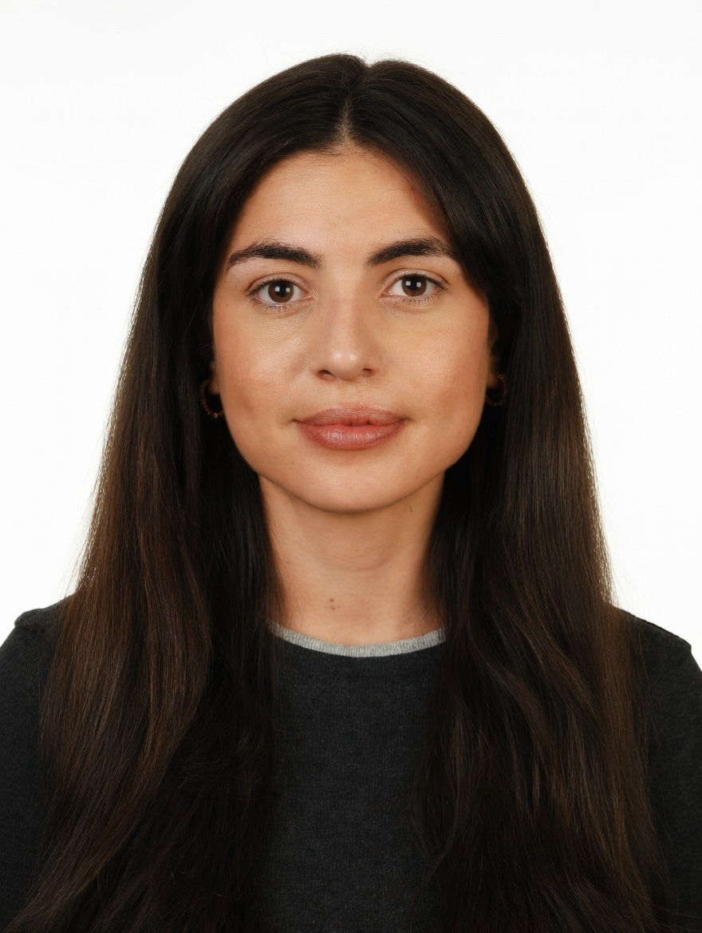
PROFESSIONAL SUMMARY

Hands-on marketing manager with 5 years across consumer brands and digital marketplaces. Brand & Marketing Manager at DoFreeze in Dubai, running paid social and search, content, influencer, affiliate and platform partnerships with a team of two, and judging campaigns on incremental sales, not reach. Previously grew 42 brands +30% GMV QoQ at Alibaba's Miravia.
WORK EXPERIENCE

Brand & Marketing Manager | Oct 2025 – Present
DoFreeze LLC · UAE F&B / FMCG group | Befit, Eurocake (incl. SMASH), Flair | sold in 50+ countries · Dubai, UAE
• Lead marketing across 50+ markets with a team of two (designer, social media exec): a year-round seasonal calendar (Ramadan, New Year, back to school), 6 product launches, and paid social and search on Meta and Google Ads
• Built the influencer programme from zero: 103 creator activations over 3 campaigns at AED 81 per content piece (market rate AED 1,000–3,500); negotiated −30% with the agency and audited its reach reporting
• Measure campaigns on incremental sales: SMASH x talabat lifted daily sales +165% vs +4.7% for a control brand (~AED 32K incremental on ~AED 8.7K spend); Befit x Noon added 4,176 incremental units (+31% vs baseline)
• Launched an affiliate programme (commission on sales, AI-built landing page, multilingual AI avatar brief), a purchase-to-enter cashback giveaway with talabat, and community activations with running, padel and yoga clubs
• Run the Shopify store; built a Claude system automating campaign planning, content and reporting (~40% less manual work)
Key Account Manager – Beauty, Fragrances & Fashion | Nov 2023 – Oct 2025
Miravia (Alibaba Group) · Alibaba's e-commerce marketplace in Spain · Madrid, Spain
• Grew 42 beauty, fragrance and fashion brands (incl. KIKO Milano) +30% GMV QoQ through pricing, assortment and promotions; owned the Flash Sales channel, reporting to the CEO against P&L targets
• Created the Beauty Club loyalty and Hot on Social programmes; as fragrance lead, onboarded 30+ stores in two months
Account Manager – XL Accounts | Sep 2022 – Nov 2023
Glovo · Food & quick-commerce delivery app | 10K+ employees · Madrid, Spain
• Co-managed large restaurant-chain accounts in the XL team (KFC, Taco Bell, La Tagliatella, Vicio): promotions and promo budgets, account performance, and cancellation and refund issues
Early Career | 2019 – 2022
Mondelez International · Línea Directa Aseguradora · Global FMCG | Spanish direct insurer · Madrid, Spain
• Category Planning Trainee, Mondelez (Aug 2021 – Aug 2022): sell-in/sell-out and promo analysis, NPD support
• Accounting Intern, Línea Directa (Jan – Dec 2019): accounting department of an insurer, working in SAP and Looker
CORE SKILLS & TOOLS

Marketing | campaign planning, content & copywriting, social media, influencer & affiliate, partnerships
Digital & Performance | Meta Ads, Google Ads (search), Instagram, TikTok, Shopify, CRO, EDM, Noon, talabat, Careem
Budgets & Partners | budget management, agency & vendor negotiation, key account management, pricing, go-to-market
Data & Analytics | ROI, ROAS, incremental uplift vs control, KPI reporting, P&L targets, Looker, Power BI, SAP
Tools & AI | Claude (AI automation), ChatGPT, Canva, Photoshop, Illustrator, Notion, Excel (Expert)
EDUCATION

Bachelor's in Business Administration — CUNEF Universidad, Madrid | 2016 – 2020
Specialisation: E-Commerce · Fashion Industry · Thesis grade: 9.5/10
Google E-Commerce Certificate · Google Digital Marketing Certificate
LANGUAGES

Spanish | Native | English | Professional C1

